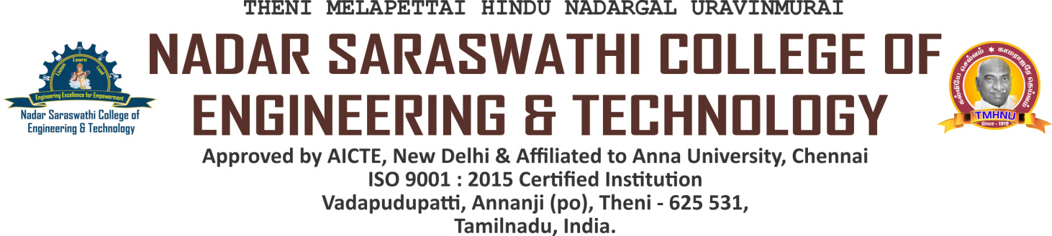

NAAC DVV CLARIFICATIONS

**CRITERION 5 - STUDENT SUPPORT AND PROGRESSION**

**Documents relating to placement cell such as brochures**

|  |  |  |  |  |  |
| --- | --- | --- | --- | --- | --- |
| **S. No** | **Date** | **Name of the activity** | **Target audience** | **Number of students attended / participated** | **link to relevant document** |
|  | 18.02.2023 | How to Crack Competitive Exams | All UG III Year | 166 | [VIEW](https://nscet.org/ssr/dvv-clarification/c5/5.2.1/5.2.1 placement events/1REPORT22-23II III_11-17.pdf) |
|  | 04.08.2022 | Logical & Verbal Aptitude Training Program | All UG III Year | 199 | [VIEW](https://nscet.org/ssr/dvv-clarification/c5/5.2.1/5.2.1 placement events/2REPORT22-23II III_3-10.pdf) |
|  | 02.02.2023 | A Career Guidance Program: Pathway to Success | All UG IV Year | 174 | [VIEW](https://nscet.org/ssr/dvv-clarification/c5/5.2.1/5.2.1 placement events/3Report22-23 IV_3-9.pdf) |
|  | 12.07.2021 | How to Crack Civil Service Exam | All UG III Year | 175 | [VIEW](https://nscet.org/ssr/dvv-clarification/c5/5.2.1/5.2.1 placement events/4Report21-22II III_11-17.pdf) |
|  | 10.09.2021 | Quantitative & Verbal Aptitude Training Program | All UG III Year | 167 | [VIEW](https://nscet.org/ssr/dvv-clarification/c5/5.2.1/5.2.1 placement events/5Report21-22II III_3-10.pdf) |
|  | 07.02.2022 | Career Guidance Program: Coding your Future | All UG IV Year | 162 | [VIEW](https://nscet.org/ssr/dvv-clarification/c5/5.2.1/5.2.1 placement events/6Report21-22IV_3-9.pdf) |
|  | 07.09.2020 | Tips to crack GATE Exam | All UG III Year | 164 | [VIEW](https://nscet.org/ssr/dvv-clarification/c5/5.2.1/5.2.1 placement events/7Report20-21II III_11-17.pdf) |
|  | 07.12.2020 | Reasoning and Verbal Aptitude Training Program | All UG III Year | 156 | [VIEW](https://nscet.org/ssr/dvv-clarification/c5/5.2.1/5.2.1 placement events/8Report20-21II III_3-10.pdf) |
|  | 11.01.2021 | Career Guidance: Charting Success in Engineering | All UG IV Year | 230 | [VIEW](https://nscet.org/ssr/dvv-clarification/c5/5.2.1/5.2.1 placement events/9Report20-21IV_3-9.pdf) |
|  | 14.09.2019 | How to succeed in GATE Exam | All UG III Year | 232 | [VIEW](https://nscet.org/ssr/dvv-clarification/c5/5.2.1/5.2.1 placement events/10Report19-20II III_11-17.pdf) |
|  | 08.01.2020 | Logical & Verbal Aptitude Training Program | All UG III Year | 159 | [VIEW](https://nscet.org/ssr/dvv-clarification/c5/5.2.1/5.2.1 placement events/11Report19-20II III_3-10.pdf) |
|  | 03.02.2020 | Career Roadmap: Student to Professional | All UG IV Year | 202 | [VIEW](https://nscet.org/ssr/dvv-clarification/c5/5.2.1/5.2.1 placement events/12Report19-20IV_3-9.pdf) |
|  | 18.11.2018 | Career Opportunities in GATE Field | All UG III Year | 205 | [VIEW](https://nscet.org/ssr/dvv-clarification/c5/5.2.1/5.2.1 placement events/13Report18-19II III_11-17.pdf) |
|  | 28.08.2018 | Quantitative & Verbal Aptitude Training Program | All UG III Year | 212 | [VIEW](https://nscet.org/ssr/dvv-clarification/c5/5.2.1/5.2.1 placement events/14Report18-19II III_3-10.pdf) |
|  | 04.02.2019 | Career Guidance: Powering up Careers | All UG IV Year | 187 | [VIEW](https://nscet.org/ssr/dvv-clarification/c5/5.2.1/5.2.1 placement events/15Report18-19IV_3-9.pdf) |